# Chapter – 1 Introduction of Information Technology (IT)

#### Information Technology –

Set of tools, processes, and methodologies (such as coding, programming, data communication, data conversion, storage & retrieval, system analysis & design, system control) and associated equipment employee to collect process and present information. In broad terms, it also includes office automation, multimedia and Tele – communication.

Information Technology, a source we call the **“computer”**, that can show you what information via Tele-portal, scoping, working calibration for transmitting throughout the world.

More commonly known as I.T. is the most popular career and the fastest growing industry in the world. There are several success stories about people who choose this field for a career and are now on top of their game.

Few reasons for why people choose IT -

⇨ Low cost of education

The biggest advantage of choosing information technology for a career is that it has very low cost of education as compared to many other career choices. You don’t need degree to become an I.T. professional. Instead, you can get quick training to be certified in specific areas of information technology. This way you save huge amounts of money that you may have otherwise spent on years of college tuition.

⇨ Fastest changing industry

The information technology industry operates at a speed much faster than any other industry and for this reason, there’s always a significant demand for highly skilled workers with the innovations in cloud computing, big data and cyber security an aspiring I.T. professional has many avenues to pursue and grow from and I.T. professional never stops learning, and must always stay on top of the latest technology trend in order to be successful in the field. The more training and knowledge the I.T. professional has the more employable he or she will be.

⇨ Better income

It is well known fact that information technology professionals are paid well, compared to other professionals. An I.T. professional with the right mix of certifications & experience can find a permanent position in either the public or private sector. Recently many companies have been extensively hiring experts in cloud computing, cyber security and network security to help

enhance their current systems.

Master of Computer Application

MCA is a part of information technology. In this age of computers and everything being digitalized, knowledge about machines is very important. It helps the person have a distinct advantage over the others who do not have a degree in computer applications. The domain is growing a rapid pace. In the 1990’s with the advent of globalization computers grew in prominence and slowly started to replace the paper and files in offices. It brought down the cost to quite an exist.

MCA is a three year undergraduate degree course. Students will be taught subjects which are related to the technological applications that are requires in today’s practical work field.

1. Skills to be learnt –

Students who study for a master of computer application (MCA) will get skills and information not only about computer and information technology but also in communication, organization and management.

One also get to learn programming languages such as C, C++, JAVA, JavaScript, HTML&

CSS, SQL, FoxPro etc.

1. Career opportunities –

MCA given a number of opportunities to individuals to go ahead and shine in their lives. The opportunities available for people doing MCA are galore. A few of them like software programmer, system and network administrator, web designer, faculty for computer science / communication technology etc. the range of chances in information technology are immense.

According to our Singhania University we have learnt many theory & practical subjects –

* + First Year
    - Management and accounting
    - Computer fundamental
    - PC software
    - Fundamentals of C Programming
    - Data structure and algorithm
    - Multime9*/dia Basic
  + Second year
    - Communication skills
    - Database management system
    - Client server technology
    - Java Programming
    - C++ Programming
    - Computer Graphics
  + Third year
    - Visual Basic Programming
    - Relational database management system (ORACLE / SQL)
    - E - Commerce
    - Computer Network and Mobile Computing
    - Internet tools & website development (JavaScript, ASP)
    - Management Information System

Chapter – 2 Introduction to Project

The project is Supermarket Billing System software for monitoring and controlling the transactions in a supermarket.

The project **JustBilling Supermarket Software** is developed on visual basic language which mainly focuses on basic operation in a supermarket like – adding new employee, adding new products, updating information of employee, searching products and employees and facility to generate bills of customers and calculate total sales amount of the supermarket.

**JustBilling Supermarket Software** is a windows application designed to help staff or admin to maintain & organize supermarket system. Our application is easy to use for both beginners & advanced users. It features a familiar and well thought – out, an attractive user interface, combined with strong insertion & deletion capabilities. It can also calculate GST amount on every product.

The application Supermarket Billing system has four main module –

* **Insertion, Deletion, Updation to database module –** User friendly input screen.
* **Extracting from the database module –**Attractive output screen.
* **Generate bill module –** generate bill of purchased products.
* **Search facility system Module –** Search for products and employees.

Many Supermarkets use this type of billing system for make their work easy. It is also improved according to requirements of sellers and users. In this Billing System we can maintain the security feature also.

Why it is made –

The main objective of this project is to provide a friendly environment to maintain the details of products and employees and generate bill for customers. The main purpose of this project is replace the manually work.

What Language –

Visual Basic .Net Language

Visual basic (VB) is a 3rdgeneration event-driven programming language developed by Microsoft for their operating system windows. Visual basic is a widely understood high level programming language, written using simple English. Like – words & syntax.

It is an interpreted language. Code can be run immediately after being written. Having an interpreter makes its simpler to use, as there is no need for the computer to compile the code, possibly finding errors to fix, before the compiled version can be run. Once the code is working, it can be compiled into an .exe file so that it will run on all modern windows computers, whether VB is installed or not. The language allows a beginning programmer to produce professional – looking windows applications, as its include drawing tools to create

normal windows and structures which allow programs to be adapted for use with the internet. VB will not run on operating systems other than windows.

Visual Basic has its origin in basic which was developed round about the year 1960, when high level languages were just being introduced to the computer community. Microsoft has made it extremely powerful by gearing all its good features to the windows environment.

Evaluation of Visual Basic –

VB 1.0 was introduced in 1991. The drag and drop design for creating the user interface is derived from prototype from generator developed by Allan cooper and his company called Tripod. Microsoft contracted with cooper and his associates to develop Tripod into a programmable form system for windows 3.0, under the code name Ruby (no relation to the Ruby programming language). Tripod did not include a programming language at all. Microsoft decided to combine Ruby with the basic language to create Visual Basic.

Need of Visual Basic –

Visual Basic is easy to learn programming language. With Visual Basic you can develop windows based applications and Games. Visual Basic is much easier to learn than others language (like Visual C++), and yet it’s powerful programming language. Visual Basic suite more for desktop application developing than for Games developing. You can create sophisticated games using Visual Basic, Visual Basic will be probably powerful enough to suite all your application and games programming needs.

Integrated Development Environment –

The working environment in VB is often referred to as the Integrated Development Environment or IDE, because it integrates many different functions such as design, editing, compiling and debugging within a common environment. Since all our projects are developed only in the IDE.

Chapter – 3 Project & Their Facilities

JustBilling Supermarket Software System is a project which aims in developing a computerized system to maintain all the daily work of supermarket. This project has many features which are like – Admin log or Employee login. It has also a feature of GST calculation of every product. We can easily add new products and add new employees in the database. It has secured database and admin and employee can only login with a unique ID and a password.

Overall this project is ours is being developed to help in any supermarket to maintain the billing facility in the best way possible and also reduce the human efforts.

Here is a list of some features which are in provided in this application –

* Keep records of employees and products with Unique ID of every employee.
* Easily generate GST calculations on bills.
* Accurate data in the database.
* Easy way to Log-In and Log-Out.
* Bill generation of every customer on their mobile no.
* Add data of customers in the database for future use.
* No need to invest heavily on hardware.

Objective of JustBilling Supermarket Software –

1. **Automation –**The application automates each and every activity of the manual system and increases its throughput. Thus the response time of the system is very less and it works very fast.
2. **Accuracy –** The application provides the user a quick response with very accurate information regarding the bill calculation and customer detail etc. any details or system in an accurate manner, as when required.
3. **User Friendly –** The application JustBilling Supermarket Software has a very user friendly interface. Thus the users will full very easy to work on it. The application provides accuracy along with a pleasant interface. Make the present manual system more interactive, speedy and user friendly.
4. **Availability –** All the Billing details stored permanently in the database admin can see the data, whatever needed.
5. **Maintain Cost –** Reduce the cost of maintenance. It is standalone application so no required of cost for maintain it.

Chapter – 4 Project Design

The project design process is not a step by step. But still much of design work depends on knowledge and experience of the designs, when we start working on project design, we will face different types of problems. However, following considerations should be kept in mind during the project design phase:

Design Objectives –

The primary objective of the design of course, is to deliver the requirements as specified already. In general the following design objectives kept in mind.

Practically –

The system must be stable and can be operated by people with average.

Efficiency –

This involves accuracy, timeliness, and comprehensiveness to the system output.

Cost –

It is desirable to aim for a system with a minimum cost subject to the condition that

it must satisfy all requirements & maintain maintenance.

Flexibility –

The system should be modifiable depending on the changing needs if the user. It should also be portable to different computer system but not other than Windows OS.

Security –

This is very important aspect of the design and should cover areas of hardware reliability, fall back procedures, physical security if the data. System design involves first logical design and then physical construction of the system.

Major Project Design Activities –

Several development activities are carried out during structured design. They are database design, implementation planning, and system interface.

Design Process –

The system design process is an exercise of specifying how, the system will work. It is an interactive process which is based on what the system will be do as shown in the report. Mainly following two parts have been included in the system design process.

* 1. Output Design –

The starting point of the design process is the proper knowledge of system requirements which will normally be converted on terms of output.

* 1. Input Design –

Once the output requirements have been finalized the next step in to find out what data need to be made available to the system to procedure the desired outputs.

Data Flow Diagrams of JustBilling Supermarket Software:

* 4.1 DFD Level 0



JustBilling Supermarket Software

Admin /Employee

{ Fig 4.1 : DFD level 0 }

* 4.2 DFD Level 1

**+**

Request

Request

Admin / Customer Billing

Response

System

Response

Database

{ Fig 4.2: DFD level 1 }

* 4.3 DFD Level 2

Supermarket Billing

System

Database

Interaction

Store in MS Access

Admin /Employee

{ Fig 4.3: DFD level 2 }

* 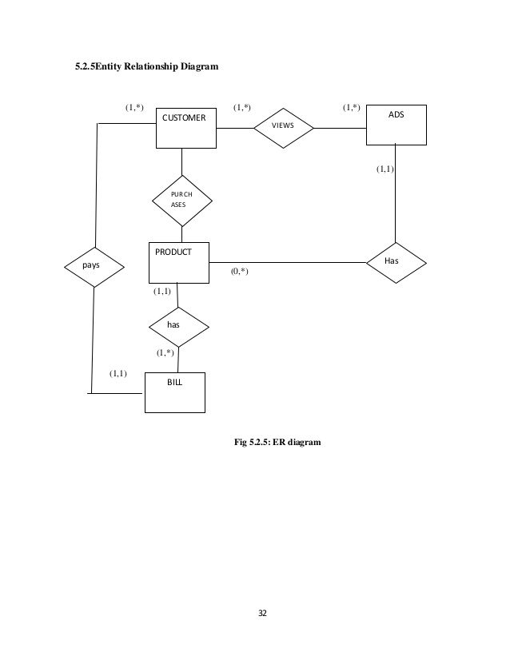***4.4 ER DIAGRAM***

{ Fig 4.4: ER Diagram }

* 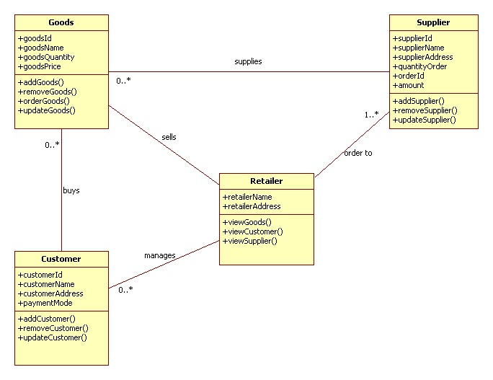***CLASS OBJECT DIAGRAM***

{ Fig 4.5: ER Diagram }

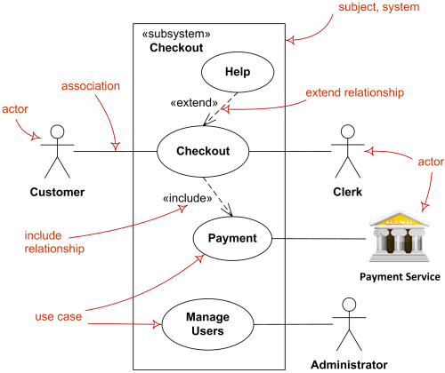

* ***USE CASE DIAGRAM***

{ Fig 4.6: ER Diagram }

Chapter - 5 All Forms and Coding of our project:

5.1:- Just billing supermarket page

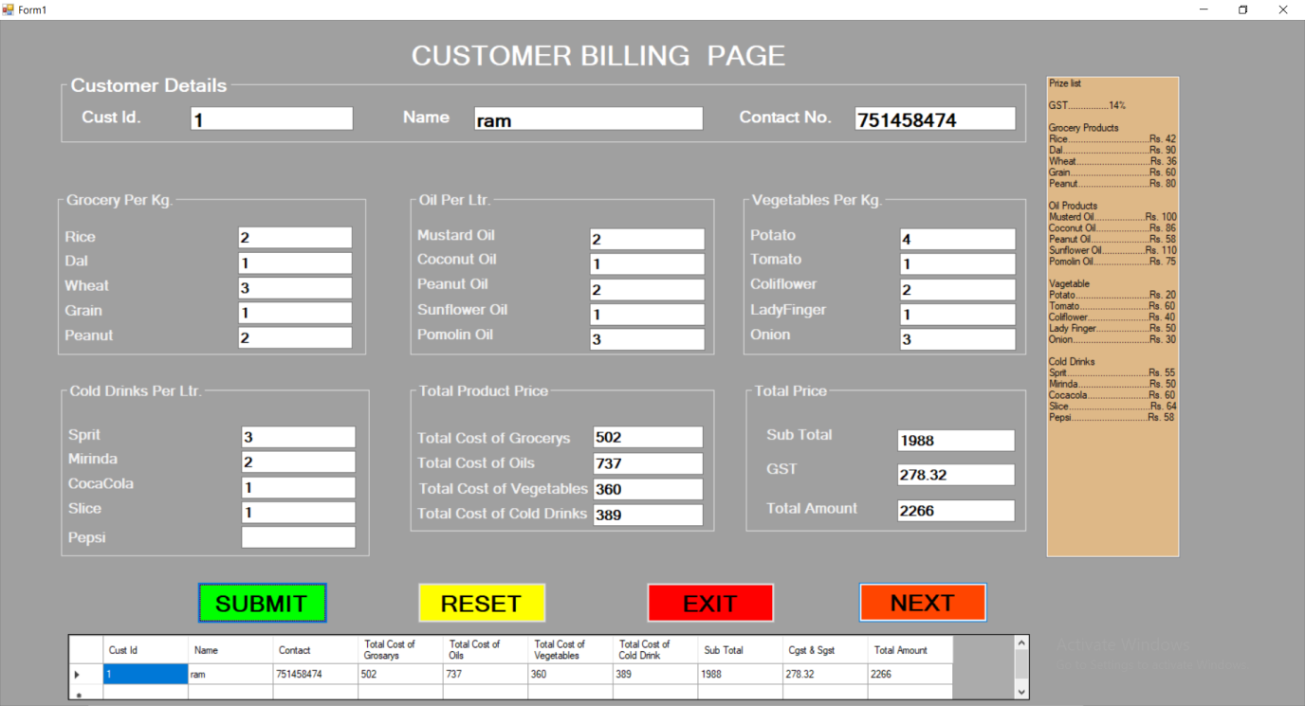

{ Fig 5.1: ER Diagram }

5.2:- cash payment page

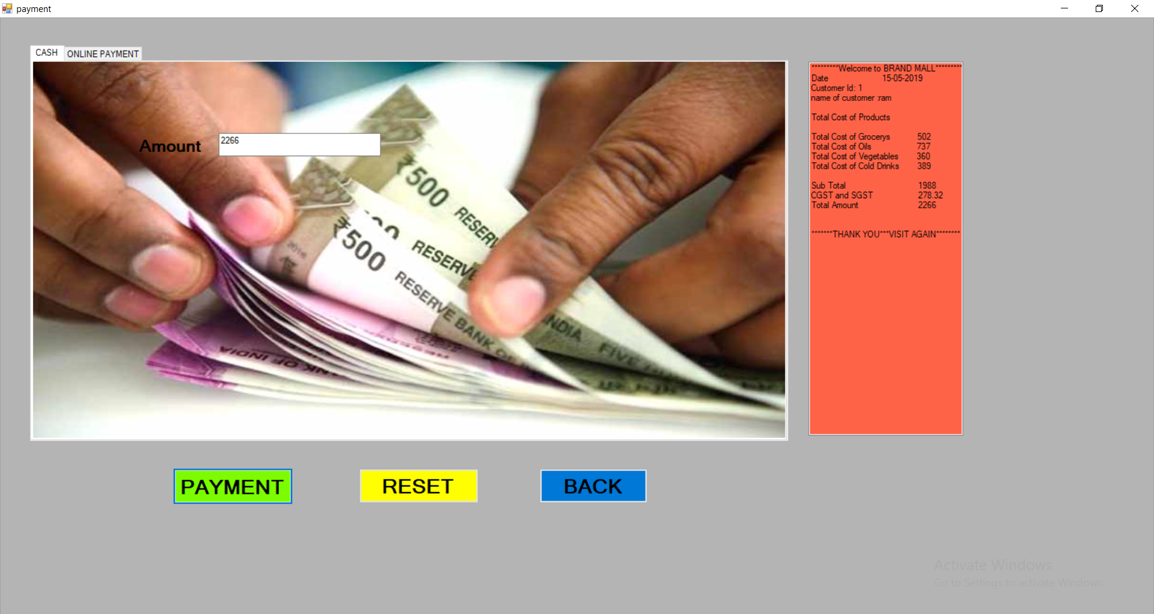

{ Fig 5.2: ER Diagram }

5.1:- online payment page

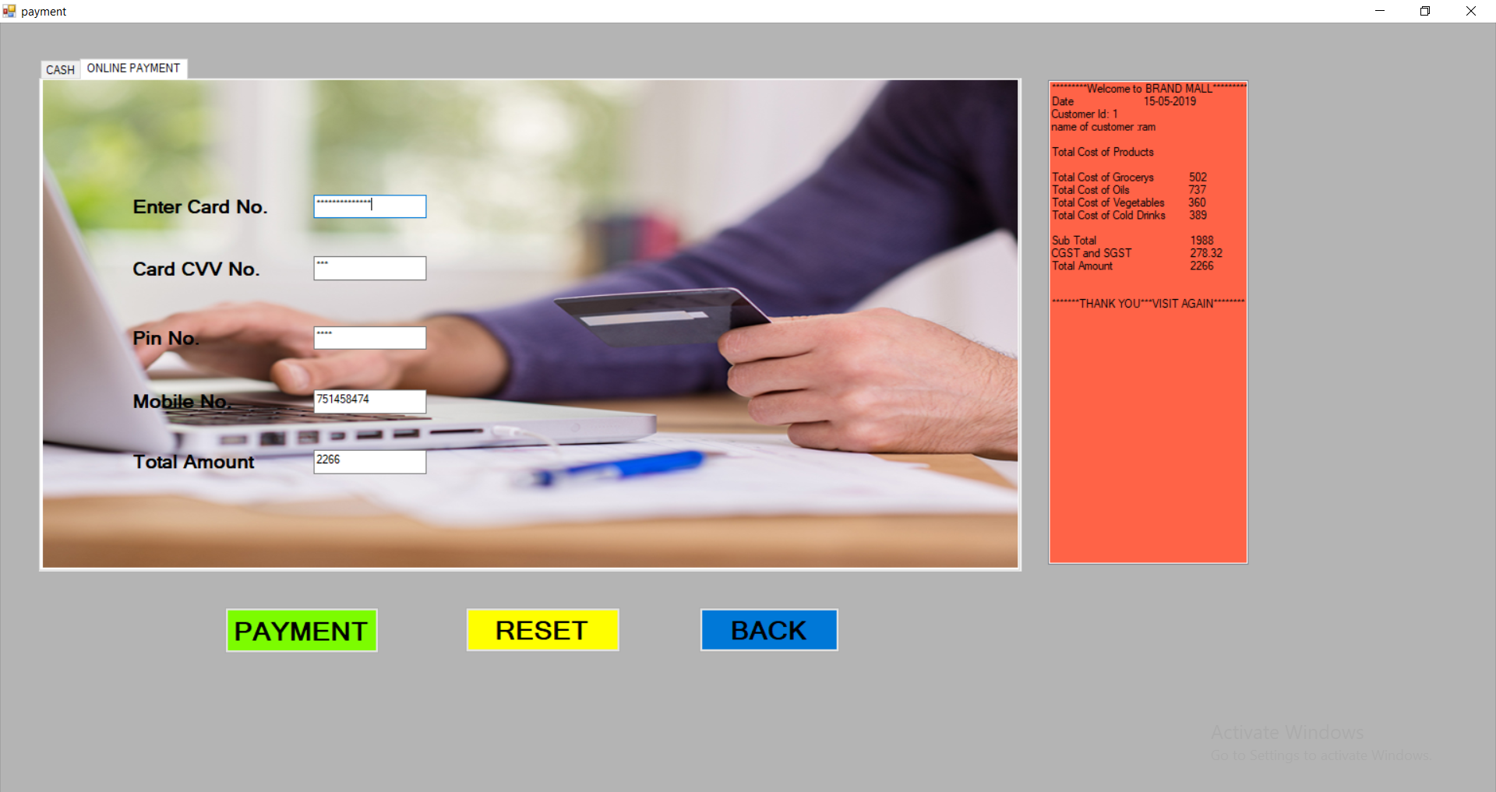

{ Fig 5.3: ER Diagram }

###### CHAPTER- 6 SOURCE CODE

6.1 : Source Code Of Form 1

Public Class Form1

Public t As Integer

Public r2 As Integer

Public r3 As Integer

Public re As Integer

Public r4 As Integer

Public r, d, w, g, p, r1, d1, w1, g1, p1 As Integer

Public m, c, pe, sun, po, m1, c1, pe1, sun1, po1 As Integer

Public pot, col, tom, lad, oni, pot1, col1, tom1, lad1, oni1 As Integer

Public sp, mi, co, sl, pep, sp1, mi1, co1, sl1, pep1 As Integer

Public id, name, con As String

Private Sub Form1_Load(sender As Object, e As EventArgs) Handles MyBase.Load

Button4.Enabled = False

listBox1.Items.Add("Prize list")

listBox1.Items.Add("")

listBox1.Items.Add("GST................14%")

listBox1.Items.Add("")

listBox1.Items.Add("Grocery Products")

listBox1.Items.Add("Rice................................Rs. 42")

listBox1.Items.Add("Dal..................................Rs. 90")

listBox1.Items.Add("Wheat.............................Rs. 36")

listBox1.Items.Add("Grain...............................Rs. 60")

listBox1.Items.Add("Peanut............................Rs. 80")

listBox1.Items.Add("")

listBox1.Items.Add("Oil Products")

listBox1.Items.Add("Musterd Oil....................Rs. 100")

listBox1.Items.Add("Coconut Oil.....................Rs. 86")

listBox1.Items.Add("Peanut Oil.......................Rs. 58")

listBox1.Items.Add("Sunflower Oil.................Rs. 110")

listBox1.Items.Add("Pomolin Oil......................Rs. 75")

listBox1.Items.Add("")

listBox1.Items.Add("Vagetable")

listBox1.Items.Add("Potato.............................Rs. 20")

listBox1.Items.Add("Tomato...........................Rs. 60")

listBox1.Items.Add("Coliflower........................Rs. 40")

listBox1.Items.Add("Lady Finger.....................Rs. 50")

listBox1.Items.Add("Onion..............................Rs. 30")

listBox1.Items.Add("")

listBox1.Items.Add("Cold Drinks")

listBox1.Items.Add("Sprit................................Rs. 55")

listBox1.Items.Add("Mirinda............................Rs. 50")

listBox1.Items.Add("Cocacola........................Rs. 60")

listBox1.Items.Add("Slice................................Rs. 64")

listBox1.Items.Add("Pepsi..............................Rs. 58")

End Sub

Public Sub button1_Click(sender As Object, e As EventArgs) Handles button1.Click

Button4.Enabled = True

'grocery product'

r = 42

d = 90

w = 36

g = 60

p = 80

r1 = Val(textBox3.Text)

d1 = Val(textBox4.Text)

w1 = Val(textBox5.Text)

g1 = Val(textBox6.Text)

p1 = Val(textBox7.Text)

t = r * r1 + d * d1 + w * w1 + g * g1 + p * p1

textBox18.Text = +t

'oil product'

m = 100

c = 86

pe = 58

sun = 110

po = 75

m1 = Val(textBox8.Text)

c1 = Val(textBox9.Text)

pe1 = Val(textBox10.Text)

sun1 = Val(textBox11.Text)

po1 = Val(textBox12.Text)

r2 = m * m1 + c * c1 + pe * pe1 + sun * sun1 + po * po1

textBox19.Text = +r2

'vegetable'

pot = 20

tom = 60

col = 40

lad = 50

oni = 30

pot1 = Val(textBox13.Text)

tom1 = Val(textBox14.Text)

col1 = Val(textBox15.Text)

lad1 = Val(textBox16.Text)

oni1 = Val(textBox17.Text)

r3 = pot * pot1 + tom * tom1 + col * col1 + lad * lad1 + oni * oni1

textBox20.Text = +r3

'cold drink'

sp = 55

mi = 50

co = 60

sl = 64

pep = 58

sp1 = Val(textBox23.Text)

mi1 = Val(textBox24.Text)

co1 = Val(textBox25.Text)

sl1 = Val(textBox26.Text)

pep1 = Val(textBox27.Text)

r4 = sp * sp1 + mi * mi1 + co * co1 + sl * sl1 + pep * pep1

textBox21.Text = +r4

Dim j, sb, gst, ta As Integer

j = t + r2 + r3 + r4

TextBox31.Text = +j

TextBox32.Text = (j * 14 / 100)

sb = Val(TextBox31.Text)

gst = Val(TextBox32.Text)

ta = sb + gst

TextBox33.Text = +ta

DataGridView1.ColumnCount = 10

DataGridView1.Columns(0).Name = "Cust Id"

DataGridView1.Columns(1).Name = "Name"

DataGridView1.Columns(2).Name = "Contact"

DataGridView1.Columns(3).Name = "Total Cost of Grosarys"

DataGridView1.Columns(4).Name = "Total Cost of Oils"

DataGridView1.Columns(5).Name = "Total Cost of Vegetables"

DataGridView1.Columns(6).Name = "Total Cost of Cold Drink"

DataGridView1.Columns(7).Name = "Sub Total"

DataGridView1.Columns(8).Name = "Cgst & Sgst"

DataGridView1.Columns(9).Name = "Total Amount"

Dim row As String() = New String() {textBox1.Text, textBox2.Text, textBox30.Text, textBox18.Text, textBox19.Text, textBox20.Text, textBox21.Text, TextBox31.Text, TextBox32.Text, TextBox33.Text}

DataGridView1.Rows.Add(row)

DataGridView1.Update()

End Sub

Private Sub Button4_Click(sender As Object, e As EventArgs) Handles Button4.Click

id = textBox1.Text

name = textBox2.Text

con = textBox30.Text

payment.Show()

Me.Hide()

End Sub

Private Sub listBox1_SelectedIndexChanged(sender As Object, e As EventArgs) Handles listBox1.SelectedIndexChanged

End Sub

Private Sub button3_Click(sender As Object, e As System.EventArgs) Handles button3.Click

Application.Exit()

End Sub

Private Sub textBox2_TextChanged(sender As Object, e As System.Windows.Forms.KeyPressEventArgs) Handles textBox2.KeyPress

If Asc(e.KeyChar) < 65 Or Asc(e.KeyChar) > 90 And

Asc(e.KeyChar) < 97 Or Asc(e.KeyChar) > 122 Then

e.Handled = True

MessageBox.Show("You can only input Character!")

End If

End Sub

Private Sub textBox1_TextChanged(sender As Object, e As System.Windows.Forms.KeyPressEventArgs) Handles textBox1.KeyPress

If Asc(e.KeyChar) < 48 Or Asc(e.KeyChar) > 57 Then

e.Handled = True

MessageBox.Show("You can only input number!")

End If

End Sub

Private Sub button2_Click(sender As Object, e As EventArgs) Handles button2.Click

textBox1.Text = ""

textBox2.Text = ""

textBox3.Text = ""

textBox4.Text = ""

textBox5.Text = ""

textBox6.Text = ""

textBox7.Text = ""

textBox8.Text = ""

textBox9.Text = ""

textBox10.Text = ""

textBox11.Text = ""

textBox12.Text = ""

textBox13.Text = ""

textBox14.Text = ""

textBox15.Text = ""

textBox16.Text = ""

textBox17.Text = ""

textBox18.Text = ""

textBox19.Text = ""

textBox20.Text = ""

textBox21.Text = ""

textBox22.Text = ""

textBox23.Text = ""

textBox24.Text = ""

textBox25.Text = ""

textBox26.Text = ""

textBox27.Text = ""

textBox28.Text = ""

textBox29.Text = ""

textBox30.Text = ""

TextBox31.Text = ""

TextBox32.Text = ""

TextBox33.Text = ""

DataGridView1.Rows.Clear()

End Sub

Private Sub textBox30_TextChanged(sender As Object, e As System.Windows.Forms.KeyPressEventArgs) Handles textBox30.KeyPress

If Asc(e.KeyChar) < 48 Or Asc(e.KeyChar) > 57 Then

e.Handled = True

MessageBox.Show("You can only input number!")

End If

End Sub

Private Sub textBox3_TextChanged(sender As Object, e As System.Windows.Forms.KeyPressEventArgs) Handles textBox3.KeyPress

If Asc(e.KeyChar) < 48 Or Asc(e.KeyChar) > 57 Then

e.Handled = True

MessageBox.Show("You can only input number!")

End If

End Sub

Private Sub textBox4_TextChanged(sender As Object, e As System.Windows.Forms.KeyPressEventArgs) Handles textBox4.KeyPress

If Asc(e.KeyChar) < 48 Or Asc(e.KeyChar) > 57 Then

e.Handled = True

MessageBox.Show("You can only input number!")

End If

End Sub

Private Sub textBox5_TextChanged(sender As Object, e As System.Windows.Forms.KeyPressEventArgs) Handles textBox5.KeyPress

If Asc(e.KeyChar) < 48 Or Asc(e.KeyChar) > 57 Then

e.Handled = True

MessageBox.Show("You can only input number!")

End If

End Sub

Private Sub textBox6_TextChanged(sender As Object, e As System.Windows.Forms.KeyPressEventArgs) Handles textBox6.KeyPress

If Asc(e.KeyChar) < 48 Or Asc(e.KeyChar) > 57 Then

e.Handled = True

MessageBox.Show("You can only input number!")

End If

End Sub

Private Sub textBox7_TextChanged(sender As Object, e As System.Windows.Forms.KeyPressEventArgs) Handles textBox7.KeyPress

If Asc(e.KeyChar) < 48 Or Asc(e.KeyChar) > 57 Then

e.Handled = True

MessageBox.Show("You can only input number!")

End If

End Sub

Private Sub textBox8_TextChanged(sender As Object, e As System.Windows.Forms.KeyPressEventArgs) Handles textBox8.KeyPress

If Asc(e.KeyChar) < 48 Or Asc(e.KeyChar) > 57 Then

e.Handled = True

MessageBox.Show("You can only input number!")

End If

End Sub

Private Sub textBox9_TextChanged(sender As Object, e As System.Windows.Forms.KeyPressEventArgs) Handles textBox9.KeyPress

If Asc(e.KeyChar) < 48 Or Asc(e.KeyChar) > 57 Then

e.Handled = True

MessageBox.Show("You can only input number!")

End If

End Sub

Private Sub textBox10_TextChanged(sender As Object, e As System.Windows.Forms.KeyPressEventArgs) Handles textBox10.KeyPress

If Asc(e.KeyChar) < 48 Or Asc(e.KeyChar) > 57 Then

e.Handled = True

MessageBox.Show("You can only input number!")

End If

End Sub

Private Sub textBox11_TextChanged(sender As Object, e As System.Windows.Forms.KeyPressEventArgs) Handles textBox11.KeyPress

If Asc(e.KeyChar) < 48 Or Asc(e.KeyChar) > 57 Then

e.Handled = True

MessageBox.Show("You can only input number!")

End If

End Sub

Private Sub textBox12_TextChanged(sender As Object, e As System.Windows.Forms.KeyPressEventArgs) Handles textBox12.KeyPress

If Asc(e.KeyChar) < 48 Or Asc(e.KeyChar) > 57 Then

e.Handled = True

MessageBox.Show("You can only input number!")

End If

End Sub

Private Sub textBox13_TextChanged(sender As Object, e As System.Windows.Forms.KeyPressEventArgs) Handles textBox13.KeyPress

If Asc(e.KeyChar) < 48 Or Asc(e.KeyChar) > 57 Then

e.Handled = True

MessageBox.Show("You can only input number!")

End If

End Sub

Private Sub textBox14_TextChanged(sender As Object, e As System.Windows.Forms.KeyPressEventArgs) Handles textBox14.KeyPress

If Asc(e.KeyChar) < 48 Or Asc(e.KeyChar) > 57 Then

e.Handled = True

MessageBox.Show("You can only input number!")

End If

End Sub

Private Sub textBox15_TextChanged(sender As Object, e As System.Windows.Forms.KeyPressEventArgs) Handles textBox15.KeyPress

If Asc(e.KeyChar) < 48 Or Asc(e.KeyChar) > 57 Then

e.Handled = True

MessageBox.Show("You can only input number!")

End If

End Sub

Private Sub textBox16_TextChanged(sender As Object, e As System.Windows.Forms.KeyPressEventArgs) Handles textBox16.KeyPress

If Asc(e.KeyChar) < 48 Or Asc(e.KeyChar) > 57 Then

e.Handled = True

MessageBox.Show("You can only input number!")

End If

End Sub

Private Sub textBox17_TextChanged(sender As Object, e As System.Windows.Forms.KeyPressEventArgs) Handles textBox17.KeyPress

If Asc(e.KeyChar) < 48 Or Asc(e.KeyChar) > 57 Then

e.Handled = True

MessageBox.Show("You can only input number!")

End If

End Sub

Private Sub textBox18_TextChanged(sender As Object, e As System.Windows.Forms.KeyPressEventArgs) Handles textBox18.KeyPress

If Asc(e.KeyChar) < 48 Or Asc(e.KeyChar) > 57 Then

e.Handled = True

MessageBox.Show("You can only input number!")

End If

End Sub

Private Sub textBox19_TextChanged(sender As Object, e As System.Windows.Forms.KeyPressEventArgs) Handles textBox19.KeyPress

If Asc(e.KeyChar) < 48 Or Asc(e.KeyChar) > 57 Then

e.Handled = True

MessageBox.Show("You can only input number!")

End If

End Sub

Private Sub textBox20_TextChanged(sender As Object, e As System.Windows.Forms.KeyPressEventArgs) Handles textBox20.KeyPress

If Asc(e.KeyChar) < 48 Or Asc(e.KeyChar) > 57 Then

e.Handled = True

MessageBox.Show("You can only input number!")

End If

End Sub

Private Sub textBox21_TextChanged(sender As Object, e As System.Windows.Forms.KeyPressEventArgs) Handles textBox21.KeyPress

If Asc(e.KeyChar) < 48 Or Asc(e.KeyChar) > 57 Then

e.Handled = True

MessageBox.Show("You can only input number!")

End If

End Sub

Private Sub textBox23_TextChanged(sender As Object, e As System.Windows.Forms.KeyPressEventArgs) Handles textBox23.KeyPress

If Asc(e.KeyChar) < 48 Or Asc(e.KeyChar) > 57 Then

e.Handled = True

MessageBox.Show("You can only input number!")

End If

End Sub

Private Sub textBox24_TextChanged(sender As Object, e As System.Windows.Forms.KeyPressEventArgs) Handles textBox24.KeyPress

If Asc(e.KeyChar) < 48 Or Asc(e.KeyChar) > 57 Then

e.Handled = True

MessageBox.Show("You can only input number!")

End If

End Sub

Private Sub textBox25_TextChanged(sender As Object, e As System.Windows.Forms.KeyPressEventArgs) Handles textBox25.KeyPress

If Asc(e.KeyChar) < 48 Or Asc(e.KeyChar) > 57 Then

e.Handled = True

MessageBox.Show("You can only input number!")

End If

End Sub

Private Sub textBox26_TextChanged(sender As Object, e As System.Windows.Forms.KeyPressEventArgs) Handles textBox26.KeyPress

If Asc(e.KeyChar) < 48 Or Asc(e.KeyChar) > 57 Then

e.Handled = True

MessageBox.Show("You can only input number!")

End If

End Sub

Private Sub textBox27_TextChanged(sender As Object, e As System.Windows.Forms.KeyPressEventArgs) Handles textBox27.KeyPress

If Asc(e.KeyChar) < 48 Or Asc(e.KeyChar) > 57 Then

e.Handled = True

MessageBox.Show("You can only input number!")

End If

End Sub

End Class

6.2: SOURCE CODE OF FORM 2

Public Class payment

Private Sub payment_Load(sender As Object, e As EventArgs) Handles MyBase.Load

Dim p As Object

Dim obj As New Form1()

Dim edate As Date = CDate("15.05.2019")

TextBox3.Text = Form1.r2

TextBox1.Text = Form1.t

TextBox5.Text = Form1.r3

TextBox4.Text = Form1.r4

TextBox1.Text = Form1.TextBox33.Text

TextBox7.Text = Form1.TextBox33.Text

recipt.Items.Add("*********Welcome to BRAND MALL*********")

recipt.Items.Add("Date" & vbTab & vbTab + edate)

recipt.Items.Add("Customer Id: " & Form1.id)

recipt.Items.Add("name of customer :" & vbTab & Form1.name)

recipt.Items.Add("")

recipt.Items.Add("Contect no" & Form1.con)

recipt.Items.Add("Total Cost of Products")

recipt.Items.Add("")

recipt.Items.Add("Total Cost of Grocerys" & vbTab & Form1.t)

recipt.Items.Add("Total Cost of Oil" & vbTab & vbTab & Form1.r2)

recipt.Items.Add("Total Cost of Vegetables" & vbTab & Form1.r3)

recipt.Items.Add("Total Cost of Cold Drinks" & vbTab & Form1.r4)

recipt.Items.Add("")

recipt.Items.Add("Sub Total" & vbTab & vbTab + Form1.TextBox31.Text)

recipt.Items.Add("CGST and SGST" & vbTab & vbTab + Form1.TextBox32.Text)

recipt.Items.Add("Total Amount" & vbTab & vbTab + Form1.TextBox33.Text)

recipt.Items.Add("")

recipt.Items.Add("")

recipt.Items.Add("*******THANK YOU***VISIT AGAIN********")

End Sub

Private Sub button1_Click(sender As Object, e As EventArgs) Handles button1.Click

Dim atn As Integer = TabControl1.SelectedTab.Tag

If TabControl1.SelectedTab Is TabPage1 Then

MsgBox("Amount Paid Successfully of Rs" + TextBox1.Text)

End If

If TabControl1.SelectedTab Is TabPage2 Then

MsgBox("Amount Paid Successfully of Rs" + TextBox7.Text)

End If

End Sub

Private Sub button2_Click(sender As Object, e As EventArgs) Handles button2.Click

TextBox1.Text = ""

TextBox3.Text = ""

TextBox4.Text = ""

TextBox5.Text = ""

TextBox6.Text = ""

TextBox7.Text = ""

End Sub

Private Sub button3_Click(sender As Object, e As EventArgs) Handles button3.Click

Form1.Show()

Me.Close()

End Sub

Private Sub TextBox4_TextChanged(sender As Object, e As EventArgs) Handles TextBox4.TextChanged

TextBox3.PasswordChar = "*"

End Sub

Private Sub TextBox5_TextChanged(sender As Object, e As EventArgs) Handles TextBox5.TextChanged

TextBox4.PasswordChar = "*"

End Sub

End Class

Chapter – 7 System Requirements of PC

|  |  |  |
| --- | --- | --- |
| **Processor** |  | **Core 2 Dual / 4.3 above** |
| **RAM** |  | **2 GB or above** |
| **HDD** |  | **500 GB / 1 TB or above** |
| **OS** |  | **Window 7 or Later** |

Chapter – 8 Conclusion

After we have completed the project we are sure the problems in the existing system world overcome. The **“Supermarket Billing System”** process made computerized to reduce human errors & to increase the efficiency. The main focus of this project is to less human efforts. The maintenance of the records is made efficient, as all the records are stored in the Access Database, through which data can be retrieved easily. The navigation control is provided in all the forms to navigate through the large amount of records. If the numbers of records are very large than user has to just type in the search string & user gets the results immediately. The editing is also made simples. The user has to just type in the required field & process the update button to update the desired field.

The products & employees are given a particular unique id no. so that they can be access correctly & without errors. Our main aim of the project is to get the correct bills and maintain the data of the supermarket.

Chapter – 9 REFERENCE

**PLACES I TOOK HELP TO BUILD THE PROJECT:**

* INTERNET
* YOUTUBE.COM
* FRIENDS
* COLLEGE FACULTY’S